Introduction to Functions of Several Variables
Table of Contents
Properties 3
Graphs (2 Variables) 4
Level Curves 5
Level Surfaces 7

Functions may have multiple independent variables. If $f\left(x, y\right)$ is a function with several variables, then $\left(x, y\right)$ is the domain. The set of values we get for $f\left(x, y\right)$ for this domain is the range.
For $g\left(x, y, z\right)=\frac{x}{\sqrt{9-x^{2}-y^{2}-z^{2}}}$ for example, the domain is $x^{2}+y^{2}+z^{2}<9$. Based on this, we can tell that the graph should be a sphere with radius $3$.

Properties
$$\left(f±g\right)\left(x, y\right)=f\left(x, y\right)±g\left(x, y\right)$$
$$\left(fg\right)\left(x, y\right)=f\left(x, y\right)g\left(x, y\right)$$
$\frac{f}{g}\left(x, y\right)=\frac{f\left(x, y\right)}{g\left(x, y\right)}$, $g\left(x, y\right)≠0$
It is not possible to form the composite of two functions. However, if one of the functions has several variables and the other has just one, a composite can be formed.
$\left(g∘h\right)\left(x, y\right)=g\left(h\left(x, y\right)\right)$, where $g$ is a function with a single variable.

Functions of multiple variables that can be written as a sum of functions in the form $cx^{m}y^{n}$ are called polynomial functions. For example, $f\left(x, y\right)=3xy^{2}+x-2$.
The quotient of two polynomial functions is called a rational function.

Graphs (2 Variables)
The graph of a function of two variables is the set of all point, $\left(x, y, z\right)$, for which $z=f\left(x, y\right)$ and $\left(x, y\right)$ is within the domain of $f$. Geometrically, this is a surface in space.
For a particular graph, the projection onto the $xy$ plane is $D$, the domain of $f$.

Level Curves
Another way to visualize a function with two variables is to use a scalar field in which the scalar $z=f\left(x, y\right)$ is assigned to the point $\left(x, y\right)$.
A scalar field can be characterized by level curves or contour lines along which the value of $f\left(x, y\right)$ is constant. Essentially, we have a line joining several points $\left(x, y\right)$ for which the same value can be found for $f\left(x, y\right)$. This value is written on the line. Several types of geographical maps use contour lines.
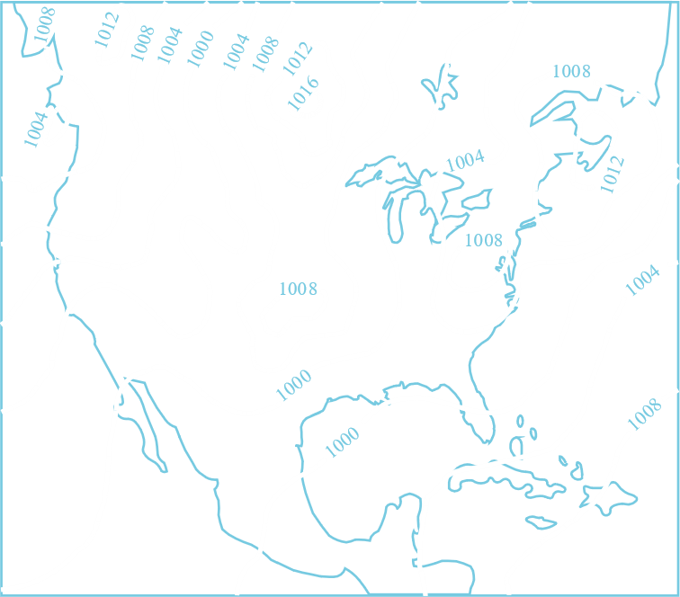
Consider that we have a function $f\left(x, y\right)=\sqrt{64-x^{2}-y^{2}}$.
$$z^{2}=64-x^{2}-y^{2}$$
$$x^{2}+y^{2}+z^{2}=64$$
Because of this, the maximum possible value of $z$ is $8$.

If we use a contour map, we can sketch a 3D graph on a 2D plane like this:


Level Surfaces
The concept of Level Curves, when extended to the third dimension, gives us Level Surfaces.
If $f\left(x, y, z\right)=4x^{2}+y^{2}+z^{2}=c$, we get ellipsoids.

